Assignment 1

Deadline: Day 3/3/2024 @ 23:59

**[Total Mark for this Assignment is 8]**

***Object Oriented Programming***

***CS230***

**Instructions:**

* You must submit two separate copies **(one Word file and one PDF file)** using the Assignment Template on Blackboard via the allocated folder. These files **must not be in compressed format**.
* It is your responsibility to check and make sure that you have uploaded both the correct files.
* Zero mark will be given if you try to bypass the SafeAssign (e.g. misspell words, remove spaces between words, hide characters, use different character sets, convert text into image or languages other than English or any kind of manipulation).
* Email submission will not be accepted.
* You are advised to make your work clear and well-presented. This includes filling your information on the cover page.
* You must use this template, failing which will result in zero mark.
* You MUST show all your work, and text must not be converted into an image, unless specified otherwise by the question.
* Late submission will result in ZERO mark.
* The work should be your own, copying from students or other resources will result in ZERO mark.
* Use **Times New Roman** font for all your answers.

Student Details:

|  |  |  |
| --- | --- | --- |
|  |  |  |
| **Name:** Waleed AlAqeel  **CRN:** 20398 |  | **ID:** 230041499 |
|  |  |  |

# Question One

***2 Marks***

*Learning Outcome(s): CLO1*

Explain the basic principles of programming, concept of language, and universal constructs of programming languages.

Explain two roles of the java virtual machine as part of java runtime environment?

Answer: 1- JVM is responsible for executing bytecode 2- and loading and verification of said bytecode.

Describe the intermediate representation of a Java program that allows a JVM to translate a program into machine-level assembly instructions.

Answer: Java code gets compiled into bytecode which is platform independent and can be used anywhere where java runtime environment can be run. Bytecode then gets translated into assembly instructions by JRE.

# Question Two

***2 Marks***

*Learning Outcome(s): CLO4*

Develop a program based on specification using programming language elements including syntax, data types, conditional statement, control structures, procedures, arrays, objects and classes.

Create a Java program that does the following:

1. Prompt the user for an input.
2. Enter your first and last names as the input.
3. Read the entered input into two variables (one variable stores the first name while the other stores the last name).
4. Using the *printf* function, print the variables in upper-case characters and each in a separate line.

(include screenshots of all program execution steps)

import java.util.Scanner;

public class Q2 {

public static void main(String[] args) {

Scanner scanner = new Scanner(System.in);

System.out.println("Enter your first name:");

String firstName = scanner.nextLine();

System.out.println("Enter your last name:");

String lastName = scanner.nextLine();

System.out.printf("First Name: %s\n", firstName.toUpperCase());

System.out.printf("Last Name: %s\n", lastName.toUpperCase());

}

}  
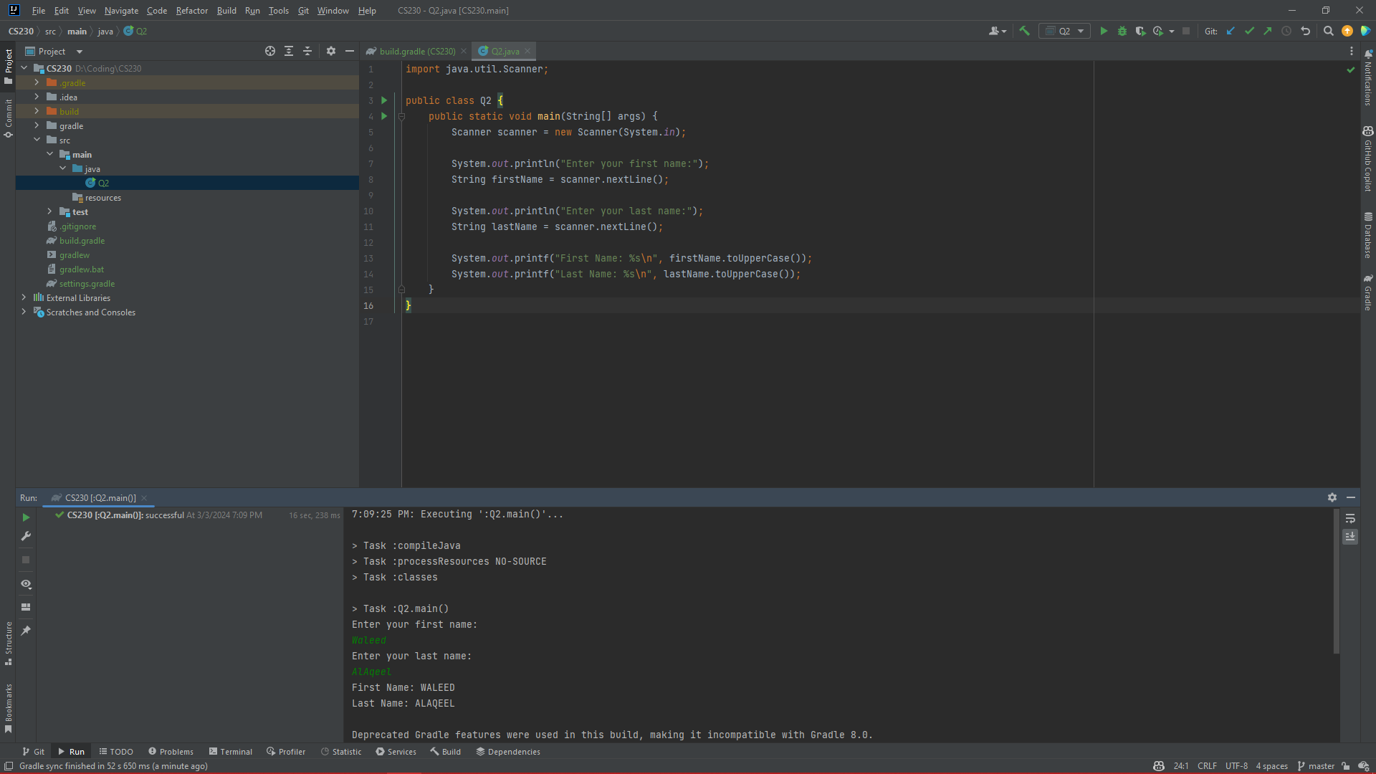

# Question Three

***2 Marks***

*Learning Outcome(s): CLO4*

Develop a program based on specification using programming language elements including syntax, data types, conditional statement, control structures, procedures, arrays, objects and classes.

The cubic polynomial function of the third degree can be represented as:

y = ax3 + bx2 + cx + d

1. Write the correct Java representation of the function without using parentheses using the Rules of Operator Precedence.

Answer: Considering the function as y = ax^3 + bx^2 + cx +d  
double y = a * x * x * x + b * x * x + c * x + d;

1. Evaluate the java representation of the function and find the value of y when,

x=3, a=1, b=2, c=3, d=4

Make sure that you show all the steps in detail.

Answer: Considering the function as y = ax^3 + bx^2 + cx +d  
int x = 3;  
int a = 1;  
int b = 2;  
int c = 3;  
int d = 4;  
double y = a * x * x * x + b * x * x + c * x + d; // 1 * 3 * 3 * 3 + 2 * 3 * 3 + 3 * 3 + 4  
// y = 1 * 3 * 3 * 3 + 2 * 3 * 3 + 3 * 3 + 4;   
System.out.println("y = " + y); // y = 58

1. Use parentheses to rewrite the java representation.

Answer: Considering the function as y = ax^3 + bx^2 + cx +d  
double y = ((a * (x * x * x)) + (b * (x * x)) + (c * x) + d);

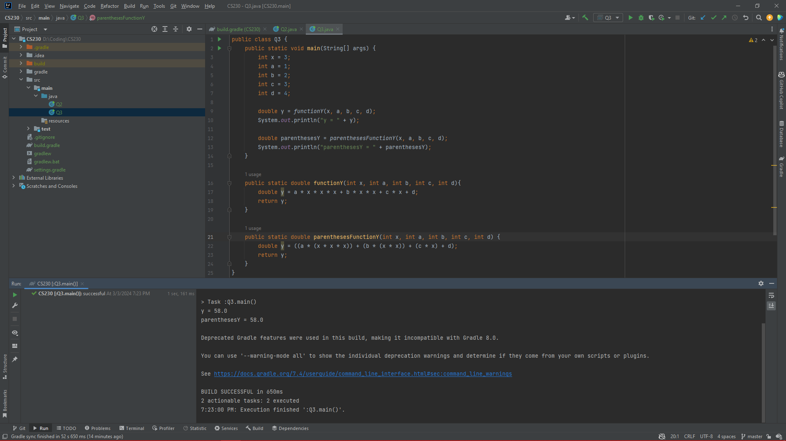

# Question Four

***2 Marks***

*Learning Outcome(s): CLO4*

Develop a program based on specification using programming language elements including syntax, data types, conditional statement, control structures, procedures, arrays, objects and classes.

Write a java program that asks the user to enter his/her name. Print a welcome message and ask the user to enter a number. Then, tell the user the type of the number (positive, negative, or zero).

*Note: you must take a screenshot of the output that shows your name in the run.*Sample of the run:

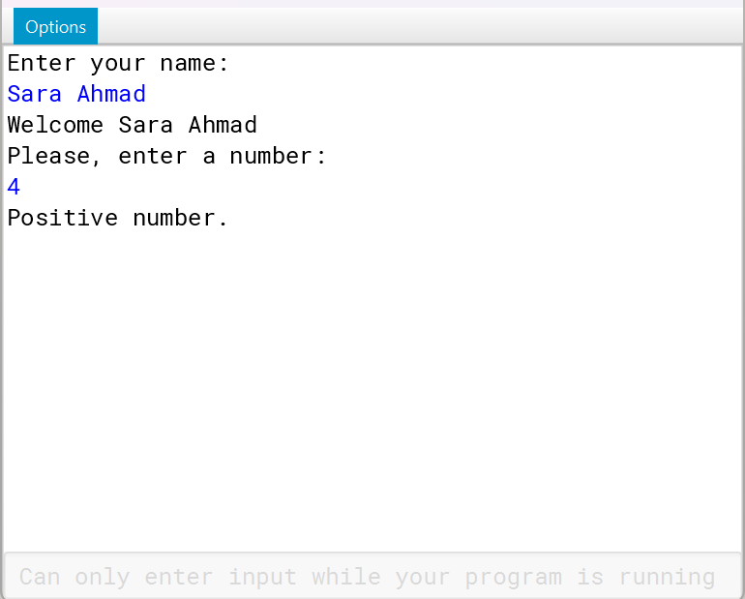

Answer:

import java.util.Scanner;

public class Q4 {

public static void main(String[] args) {

Scanner scanner = new Scanner(System.in);

System.out.println("Enter your name:");

String name = scanner.nextLine();

System.out.println("Welcome " + name);

System.out.println("Please, enter a number:");

int number = scanner.nextInt();

if(number > 0) System.out.println("Positive number.");

else if(number == 0) System.out.println("Number zero.");

// else if(number < 0) System.out.println("Negative number.");

else System.out.println("Negative number."); // Considering we covered 2 of the cases the last one will not need any checks.

}

}

